# Media Analysis - ChatGPT is the ‘Netscape moment’ for artificial intelligence’ _ Arab News

## Short Summary

The article is about ChatGPT being compared to Netscape s impact on the World Wide Web, as it has captured public imagination similarly, through a large language model LLM that can generate human-like responses, texts, and summarize based on prompts.

## Summary

1. ChatGPT is a Large Language Model (LLM) that uses unsupervised learning to generate responses, summarize texts, and produce text content based on prompts.  
2. While LLMs have practical applications in various fields such as law and academia, they lack world knowledge, common sense, and the ability to reason or perform complex tasks.  
3. The rapid evolution of LLMs will necessitate their augmentation with systems that possess common sense, an understanding of the world, ethics, and the ability to reason. This will bring them closer to how human minds operate.  
4. AI, including LLMs, has the potential to increase productivity and address economic challenges like inflation and labor costs in various countries, particularly those facing demographic changes. Saudi Arabia, with its focus on data and AI, is well-positioned to capitalize on this opportunity by localizing and extending LLMs to regional languages and exploiting its expertise in domains such as energy.

## Question 1

The metaphor used in the text to frame the discussion about ChatGPT is the "Netscape moment for artificial intelligence." This metaphor suggests that ChatGPT has had a transformative impact on public perception of AI, similar to how Netscape made the World Wide Web accessible and popular in the 1990s. Other recurring metaphors include "autocomplete on steroids" and "foundation models," which emphasize the model's capabilities in generating text based on patterns learned from large amounts of data, and its potential to serve as a base for future developments, respectively. The text also implies that, despite its limitations, ChatGPT is seen as a catalyst for innovation, productivity, and economic growth.

## Question 2

The text primarily covers the excitement surrounding ChatGPT as a significant milestone for artificial intelligence (AI), its capabilities and limitations, potential applications across various industries such as law and consulting, and its impact on productivity and economy. It also touches upon the need to augment AI with systems that have common sense, an understanding of the world, ethics, and the ability to reason.  
  
Aspects being ignored in this text include specific examples or case studies illustrating how ChatGPT is currently being used across various industries, as well as any potential challenges or drawbacks faced by these companies when integrating AI into their operations beyond the mentioned 'hallucinations' and 'misinformation'. Furthermore, it does not delve into the ethical implications of AI in terms of privacy, bias, and accountability. Lastly, there is no discussion about the potential impact of ChatGPT on employment or the workforce dynamics.

## Question 3

The Arabic World is not explicitly mentioned in this article, but it can be inferred that they could potentially leverage AI by using large language models like ChatGPT for various applications such as automatically creating the skeletons of contracts or generating articles or reports without requiring human labor. The article also suggests that localizing and extending these models to the languages and dialects of the region, and using the knowledge embedded in domains where the country is a natural leader, could be beneficial.

## Question 4

The article emphasizes that ChatGPT and similar models, while powerful, have limitations (lack of world knowledge, common sense, ability to reason) and need augmentation. It suggests that future AI should resemble human thinking more closely, with common sense, understanding of the world, ethics, and the ability to reason. The author encourages entities in Saudi Arabia to explore how AI can create value in their respective fields and industries, particularly focusing on localizing and extending these models to regional languages and domains where Saudi Arabia is a leader, such as energy.

## Sentiment

The sentiment is 3.0

## Entities

the Saudi Data, AI Authority, Aramco, AI, ANTHONY BUTLER, Anthony Butler, IBM, exempli ed, Arab News, ChatGPT, GPT, Disclaimer Views

## Highlights

#7cc867#fb5b89#c885da

## Wordcloud for #7cc867 Highlights

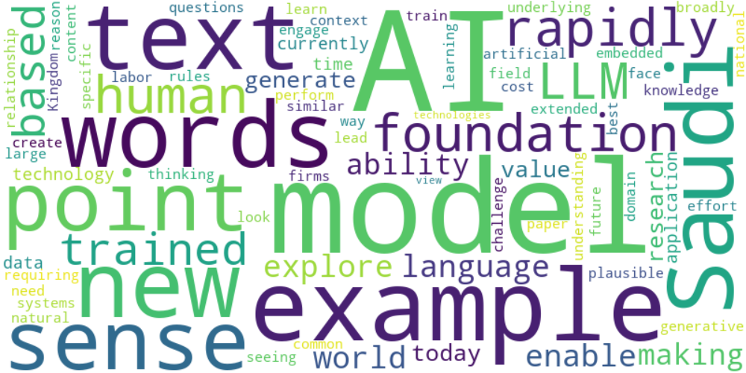

Top 10 words:

- AI: 13

- models: 8

- example: 6

- words: 5

- Saudi: 5

- text: 4

- point: 4

- sense: 4

- like: 4

- rapidly: 4

## Wordcloud for #fb5b89 Highlights

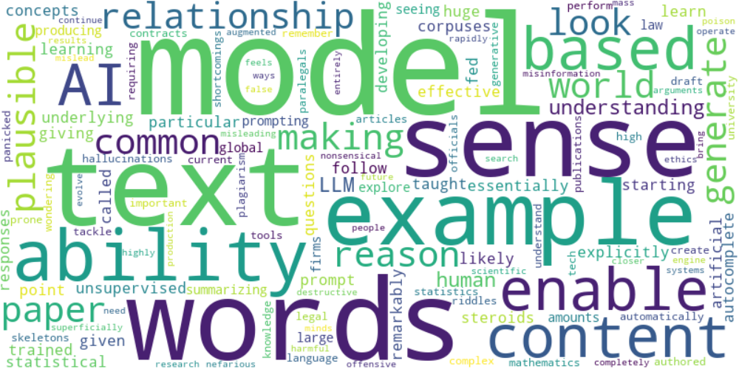

Top 10 words:

- models: 6

- words: 5

- text: 4

- sense: 4

- like: 3

- example: 3

- ability: 3

- model: 2

- content: 2

- based: 2

## Wordcloud for #c885da Highlights

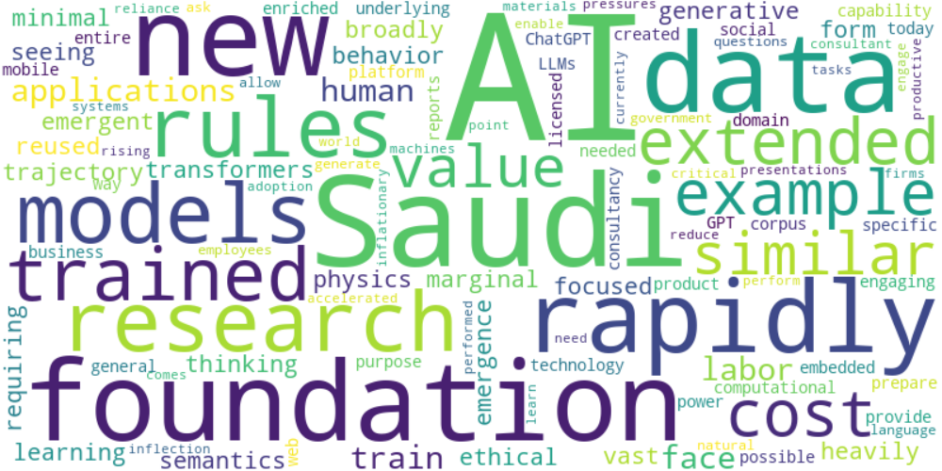

Top 10 words:

- AI: 9

- Saudi: 4

- new: 3

- rapidly: 3

- research: 2

- rules: 2

- foundation: 2

- trained: 2

- extended: 2

- example: 2